Position Sensitivity Analysis of the LNVG Kalman Filter
Author: Mario
Date: 2026-07-05
Version: Draft 1.0

Executive Summary
This report presents a sensitivity analysis of the LNVG Kalman filter used for train position estimation. The objective was to evaluate the robustness of the estimator under representative sensor perturbations affecting the TrainSpeed signal, GPS position measurements and temporary GPS signal loss.
A perturbation framework was developed to introduce controlled disturbances into the simulator while maintaining repeatable operating conditions. The resulting position and speed estimates were evaluated using quantitative performance metrics and graphical comparison of the reference and estimated trajectories.
The analysis indicates that the Kalman filter provides robust position and speed estimation for all investigated scenarios. Increasing disturbance levels lead to a gradual degradation of the estimation accuracy, while no unstable behaviour was observed.
Among the investigated scenarios, temporary GPS signal loss produces the largest position errors. Nevertheless, the estimator remains stable throughout the outage and rapidly converges towards the reference trajectory when GPS observations become available again.
Taken together, the investigated scenarios indicate that the applied sensor fusion approach provides a robust basis for train positioning. The complementary characteristics of the TrainSpeed and GPS measurements enable the estimator to maintain useful position and speed estimates even when individual measurements become degraded or temporarily unavailable.
The developed perturbation framework provides a repeatable platform for future validation and systematic tuning of the Kalman filter and may be extended with additional perturbation scenarios and performance metrics.

System Description

Objective
The purpose of this study is to evaluate the robustness of the LNVG Kalman filter position estimation under controlled sensor perturbations. The analysis investigates how disturbances affecting the available input signals influence the estimated train position and speed.
The study focuses on perturbations that are representative of practical railway operation, including TrainSpeed errors, GPS position noise and temporary GPS signal loss.

Test Environment
The analysis was performed using the LNVG simulator framework.
Reference train motion is generated by the simulator while controlled perturbations are applied to selected input signals before they reach the Kalman filter. The resulting estimated position and speed are recorded and compared with the reference trajectory.
The framework enables repeatable experiments under identical operating conditions, allowing direct comparison between different perturbation scenarios.

Evaluation Principle
Each scenario consists of one reference case and one or more perturbation cases.
For every run, the estimated position and speed are compared with the corresponding reference values. The analysis combines visual inspection of the trajectories with quantitative performance metrics in order to evaluate the sensitivity of the estimator.

Methodology

Assumptions
The analysis assumes that the Kalman filter has access only to the following input signals:
- TrainSpeed
- GpsSpeed
- GpsPosition
No additional sensor information is assumed to be available. In particular, no accelerometer measurements, odometry position signal or external track reference corrections are included in the present study.
Under these assumptions, the TrainSpeed signal represents the complete motion information available between consecutive GPS observations.

Sensitivity Analysis
The analysis was performed by introducing controlled perturbations into individual input signals while keeping all other operating conditions unchanged.
Each scenario consists of multiple test cases representing different levels of perturbation severity. The resulting estimator performance is evaluated by comparing the corresponding position and speed error metrics.
All scenarios were executed using identical train motion and simulator settings to ensure repeatability.

Performance Metrics
The estimator performance was evaluated using both graphical comparison and quantitative error metrics.
The primary metrics are:
- Position Error RMS
- Maximum Absolute Position Error
- Speed Error RMS
- Maximum Absolute Speed Error
The RMS values characterize the overall estimation accuracy, while the maximum absolute error quantifies the worst-case deviation observed during each scenario.

Perturbation Scenarios

Four perturbation scenarios were considered:
Scenario | Description
S1 | Baseline (no perturbations)
S2 | TrainSpeed noise sensitivity
S3 | GPS position noise sensitivity
S4 | GPS signal loss sensitivity
Each scenario is described in detail in the following chapters.

Baseline

Objective
The objective of the baseline scenario is to establish the nominal performance of the Kalman filter in the absence of sensor perturbations. The resulting position and speed estimation errors provide a reference for interpreting the subsequent sensitivity analyses.

Test Case
A single test case was performed using nominal simulator settings without any perturbations applied to the input signals.
Case | Description
BASELINE | Nominal operation without perturbations

Results
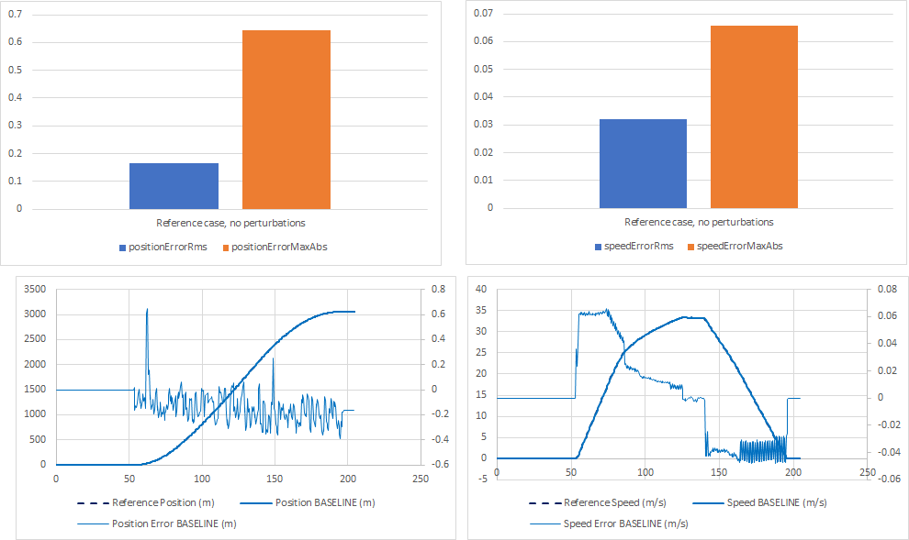
Figure 4.1 presents the baseline performance of the estimator at a motion consisting of an acceleration to approximately 33 m/s, followed by a short cruise and then brake to 0. The lower diagrams show the estimated position and speed together with the corresponding reference trajectories. X-Axis = time [s]. Left axis = Signal. Right axis = (Reference - Baseline). The upper bar charts summarize the resulting performance metrics.
Both the position and speed estimates closely follow the reference values throughout the simulation. The observed errors remain small and mainly reflect the inherent characteristics of the estimator rather than sensor disturbances.

Discussion
The baseline scenario demonstrates that the Kalman filter provides accurate position and speed estimates under nominal operating conditions. The small residual errors observed in this case establish the lower bound of the estimation accuracy and confirm that the analysis framework operates as intended.
The baseline results serve as the reference against which the perturbation scenarios presented in the following chapters are evaluated.

TrainSpeed Noise Sensitivity

5.1 Objective
The objective of this scenario is to evaluate the sensitivity of the Kalman filter to random errors affecting the TrainSpeed signal. Increasing levels of noise are introduced in order to assess how the estimation accuracy degrades as the uncertainty of the speed measurement increases.

Test Cases
Three TrainSpeed noise levels were evaluated.
Case | Description
TRAIN_SPEED_NOISE_1P | TrainSpeed noise ±1 %
TRAIN_SPEED_NOISE_2P | TrainSpeed noise ±2 %
TRAIN_SPEED_NOISE_5P | TrainSpeed noise ±5 %

Results
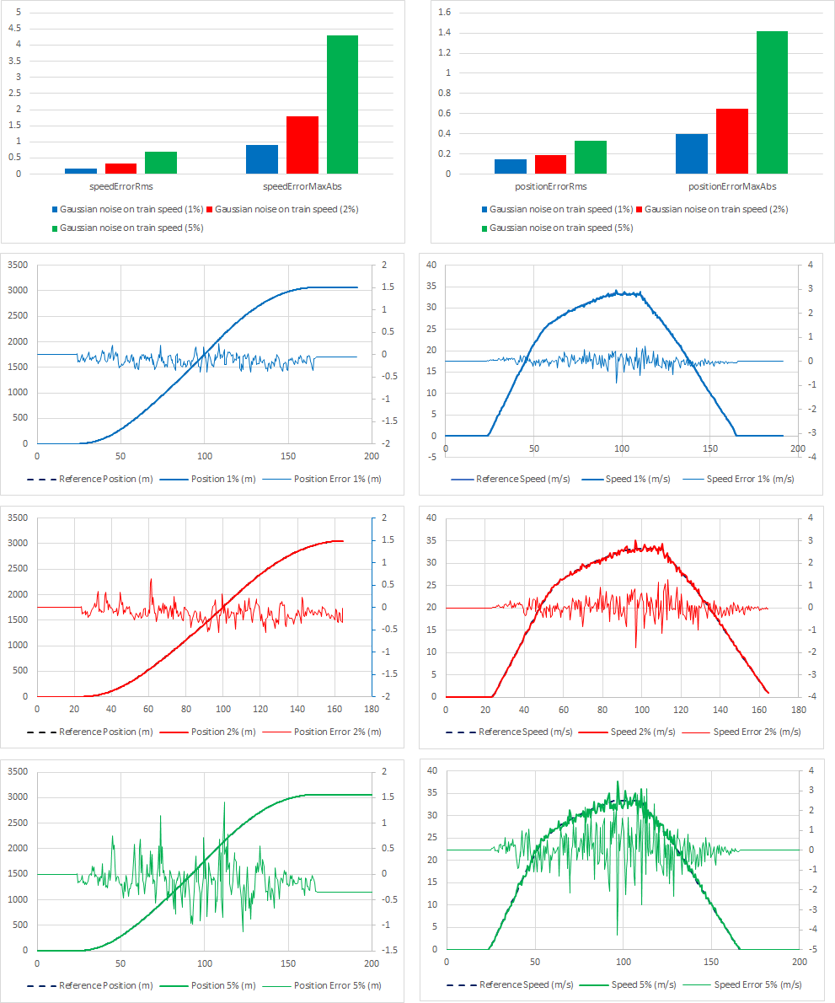
Figure 5.1 summarizes the estimator performance for all investigated TrainSpeed noise levels. The lower diagrams present the estimated position and speed together with the corresponding estimation errors, while the upper bar charts summarize the performance metrics for each test case.
As the TrainSpeed noise increases, both the position and speed estimation errors increase gradually. The deterioration is reflected in both the RMS error and the maximum absolute error.

Discussion
The results demonstrate that the estimation accuracy decreases as the TrainSpeed uncertainty increases. Nevertheless, the Kalman filter remains stable throughout all investigated noise levels.
The gradual increase in the performance metrics indicates a predictable degradation rather than an abrupt loss of estimation quality. Within the investigated range, the estimator continues to provide consistent position and speed estimates despite increasing disturbances in the TrainSpeed signal.

GPS Position Noise Sensitivity

Objective
The objective of this scenario is to evaluate the sensitivity of the Kalman filter to random errors affecting the GPS position measurements. Increasing levels of GPS position noise are introduced to assess their influence on the estimated train position and speed.

Test Cases
Three GPS position noise levels were evaluated.
Case | Description
GPS_POSITION_NOISE_1M | GPS position noise ±1 m
GPS_POSITION_NOISE_3M | GPS position noise ±3 m
GPS_POSITION_NOISE_10M | GPS position noise ±10 m

Results
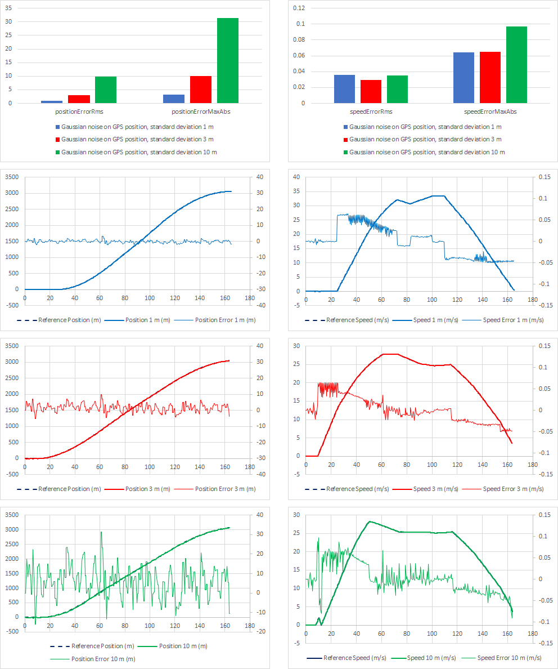
Figure 6.1 summarizes the estimator performance for the investigated GPS position noise levels. The upper diagrams present the estimated position and speed together with the corresponding estimation errors, while the lower bar charts summarize the performance metrics for each test case.
Increasing GPS position noise results in a gradual increase in the position estimation error. The speed estimate is affected to a much smaller extent, indicating that the estimator effectively attenuates random disturbances in the GPS position measurements.

Discussion
The results show that the Kalman filter remains stable for all investigated GPS noise levels. Although the position accuracy decreases as the GPS uncertainty increases, the degradation is gradual and well behaved.
The limited influence on the speed estimate indicates that the estimator effectively suppresses random GPS position disturbances while maintaining a consistent estimate of the train motion.

GPS Signal Loss Sensitivity

Objective
The objective of this scenario is to evaluate the behaviour of the Kalman filter during temporary GPS signal loss. Different outage durations are investigated to assess how the estimation accuracy evolves when GPS measurements are unavailable and how rapidly the estimator recovers when GPS observations become available again.

Test Cases
Three GPS outage durations were evaluated.
Case | Description
TUNNEL_15S_TS_NOISE_2P | GPS unavailable for 15 s
TUNNEL_30S_TS_NOISE_2P | GPS unavailable for 30 s
TUNNEL_60S_TS_NOISE_2P | GPS unavailable for 60 s

Results
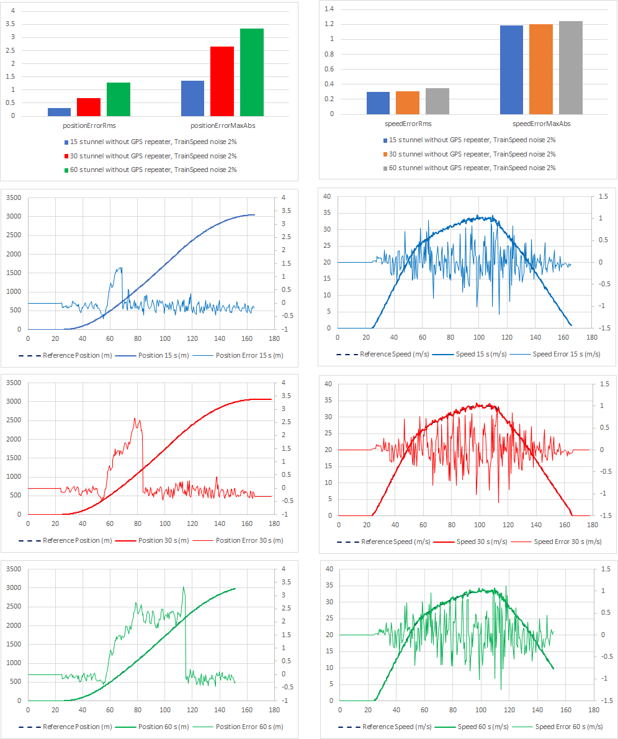
Figure 7.1 summarizes the estimator performance for the investigated GPS outage durations. The lower diagrams present the estimated position and speed together with the corresponding estimation errors, while the upper bar charts summarize the performance metrics for each test case.
Longer GPS outages lead to increased position estimation errors, while the speed estimate is affected only moderately. After GPS observations become available again, the position estimate converges rapidly towards the reference trajectory.

Discussion
As expected, the position error increases with the duration of the GPS outage. During the tunnel passage, the Kalman filter propagates the position estimate using the TrainSpeed signal, causing the position uncertainty to grow gradually. Nevertheless, the estimator remains stable throughout all investigated test cases.
When GPS observations become available again, the position estimate rapidly converges towards the reference trajectory. Even for the longest investigated outage, the accumulated position error remains bounded and no unstable behaviour is observed.

Discussion

Main Findings
F1. Robustness
The sensitivity analysis indicates that the Kalman filter provides robust position and speed estimation under all investigated perturbation scenarios. No unstable behaviour was observed within the investigated disturbance levels.
F2. Sensitivity to sensor disturbances
Random disturbances affecting either the TrainSpeed signal or the GPS position measurements result in a gradual degradation of the estimation accuracy. The estimator behaviour remains predictable throughout the investigated disturbance range.
F3. GPS signal loss
Temporary GPS signal loss produces the largest position errors. Nevertheless, the estimator remains stable throughout the outage and rapidly converges towards the reference trajectory when GPS observations become available again.
F4. Sensor fusion
Taken together, the investigated scenarios indicate that the applied sensor fusion approach provides a robust basis for train positioning. The complementary characteristics of the TrainSpeed and GPS measurements enable the estimator to maintain useful position and speed estimates even when individual measurements become degraded or temporarily unavailable.

Limitations
L1. Available sensor information
The present study considers only the signals TrainSpeed, GpsSpeed and GpsPosition. Additional information that may be available in the production system, such as track reference corrections or other positioning aids, was intentionally excluded in order to isolate the influence of the investigated sensor signals.
L2. Operating scenario
The analysis was performed using one representative train run. Different routes, operating conditions and train dynamics may influence the quantitative results, although the qualitative observations are expected to remain valid.
L3. Perturbation scenarios
Only selected perturbation types and disturbance magnitudes were investigated. Other perturbation models may provide additional insight into the behaviour of the estimator.

Further Work
FW1. Extended perturbation studies
The perturbation framework may be extended with additional perturbation scenarios, including combined sensor disturbances and position-based perturbation activation for geographically localized events.
FW2. Extended performance metrics
The evaluation may be complemented with additional performance metrics, including overshoot, settling time and recovery time. A complementary study based on idealized speed profiles, such as step, ramp and constant-speed operation, could further characterize the transient behaviour of the estimator.
FW3. Kalman filter tuning
The developed perturbation framework provides a suitable platform for systematic Kalman filter tuning. Alternative filter parameters or estimation models may be evaluated objectively under repeatable operating conditions with the objective of reducing estimation deviations during dynamic operation.
FW4. Extended operational validation
Future investigations may include additional routes, train configurations and operating conditions to further assess the robustness of the estimator.

